TC Cockpit Create Project Refactoring Part 2 Deployment Guide

Revision History
Author | Revision Number | Date
isv | 1.0 | 01/29/2012

Deployment Instructions 3
1. Organization of Submission 3
2. Application Setup 3
2.1 Ant .Properties File 3
2.2 Build Scripts Setup 3
3. Database Setup 4
4. Deployment Instructions 4
5. Starting 4
6. Verification 4
7. Resource Contact List 11

Deployment Instructions

Organization of Submission

The content of submission follows directory structure provided below:

direct

Contains the sources for TopCoder Direct application added/updated in the course of this assembly. This directory replicates the application development distribution structure and includes only updated and new files.

docs

Contains this document which is the Deployment Guide for the TC Cockpit Create Project Refactoring Part 2 assembly.

test_files

Contains the SQL scripts with sample test data to be used for review purposes only.

Application Setup

The application is expected to be deployed to the following environment:

JRE 1.5
JBoss 4.2.3.GA
Informix DS 11.0

Ant .Properties File
New configuration file has been defined to configure Project Service Facade component:

Property Name | File property is stored | Example Setting
createForum | conf/ProjectServiceFacade.xml | A flag indicating whether the service facade should really perform (if true) or just simulate (if false) the project forum creation
forumBeanProviderUrl | conf/ProjectServiceFacade.xml | An URL referencing the JNDI provider for Forums EJB

Build Scripts Setup

The build script for TopCoder Direct application (build.xml) provides the following targets which are to be used:

- dist-backend – re-builds all backend coomponents
- deploy – builds and deploys the TopCoder Direct application to target server.

The build script for each of Project Service, Project Service Facade, Contest Service Facade components (build.xml) provides the following target which is to be used:

- dist_tcs – builds the library JAR for the component and put it to TC Direct application development distribution

Database Setup

Follow the instructions from TopCoder Databases Deployment Guide document from http://www.topcoder.com/wiki/display/docs/TopCoder+Databases+Setup+Guide for setting up the database.

No changes to existing databases have been introduced with this assembly.

Deployment Instructions

This section provides the instructions for integrating and deploying the changes from TC Cockpit Create Project Refactoring Part 2 assembly in Production environment.

- Merge the updated/new code from this submission into development distribution for TC Direct application
- Build each of Project Service, Project Service Facade, Contest Service Facade components using ant dist_tcs command for each component or re-build all backend components with ant dist-backend command
- Build and deploy TopCoder Direct application using ant deploy command
- Copy static files to /mnt/apache/tcdocs directory using ant deploy-apache-static command.

If necessary consult following online documentation for details on building and deployment of TopCoder Direct application:

http://apps.topcoder.com/wiki/display/docs/TC+Direct+Setup+Guide

Starting

- Build and deploy the TopCoder Direct application
- Start JBoss server instance hosting TopCoder Direct application

Verification

- Login to TC Direct application using URL like http://cockpit.cloud.topcoder.com/direct/
  - The All Active Contests page must be displayed.

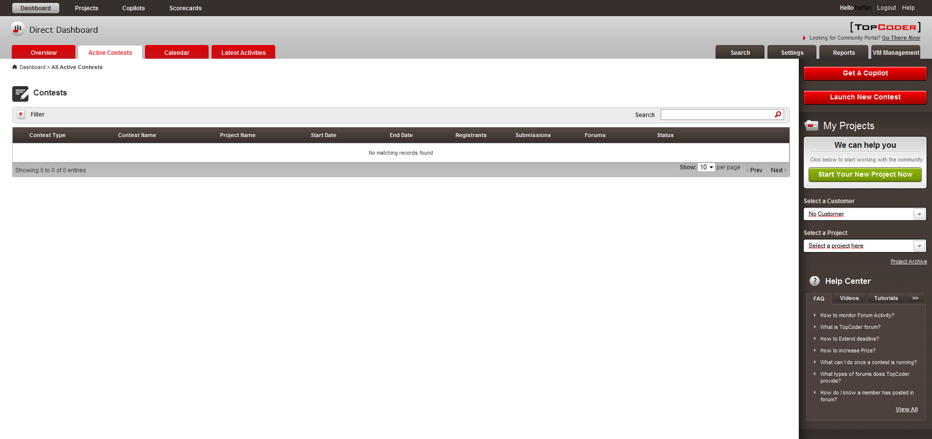

- Click Start Your New Project Now button on the right side panel.
  - The page for starting the process of creating new project must be displayed

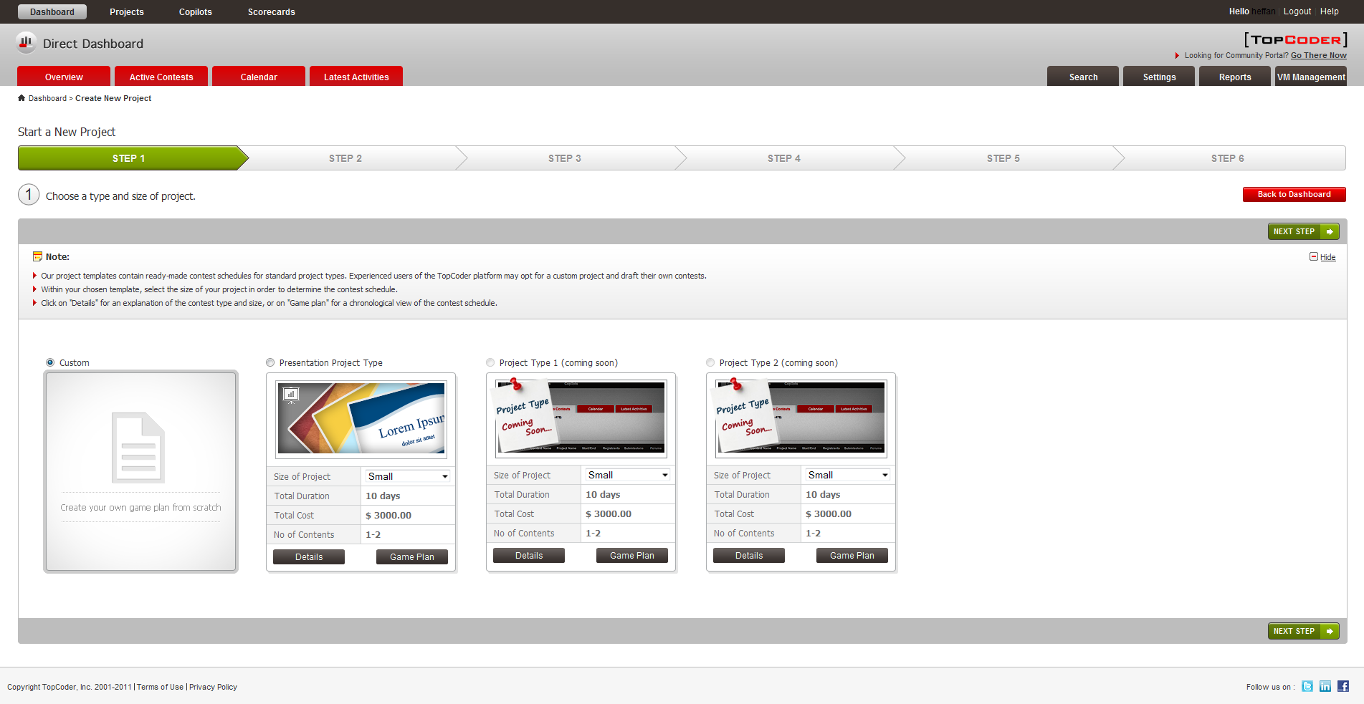

- Enter the data necessary for creating new project and proceed to page with Step 4. On that page add some users and grant them a permissions for accessing the project. Finish the project creation process.
  - The project must be created successfully.

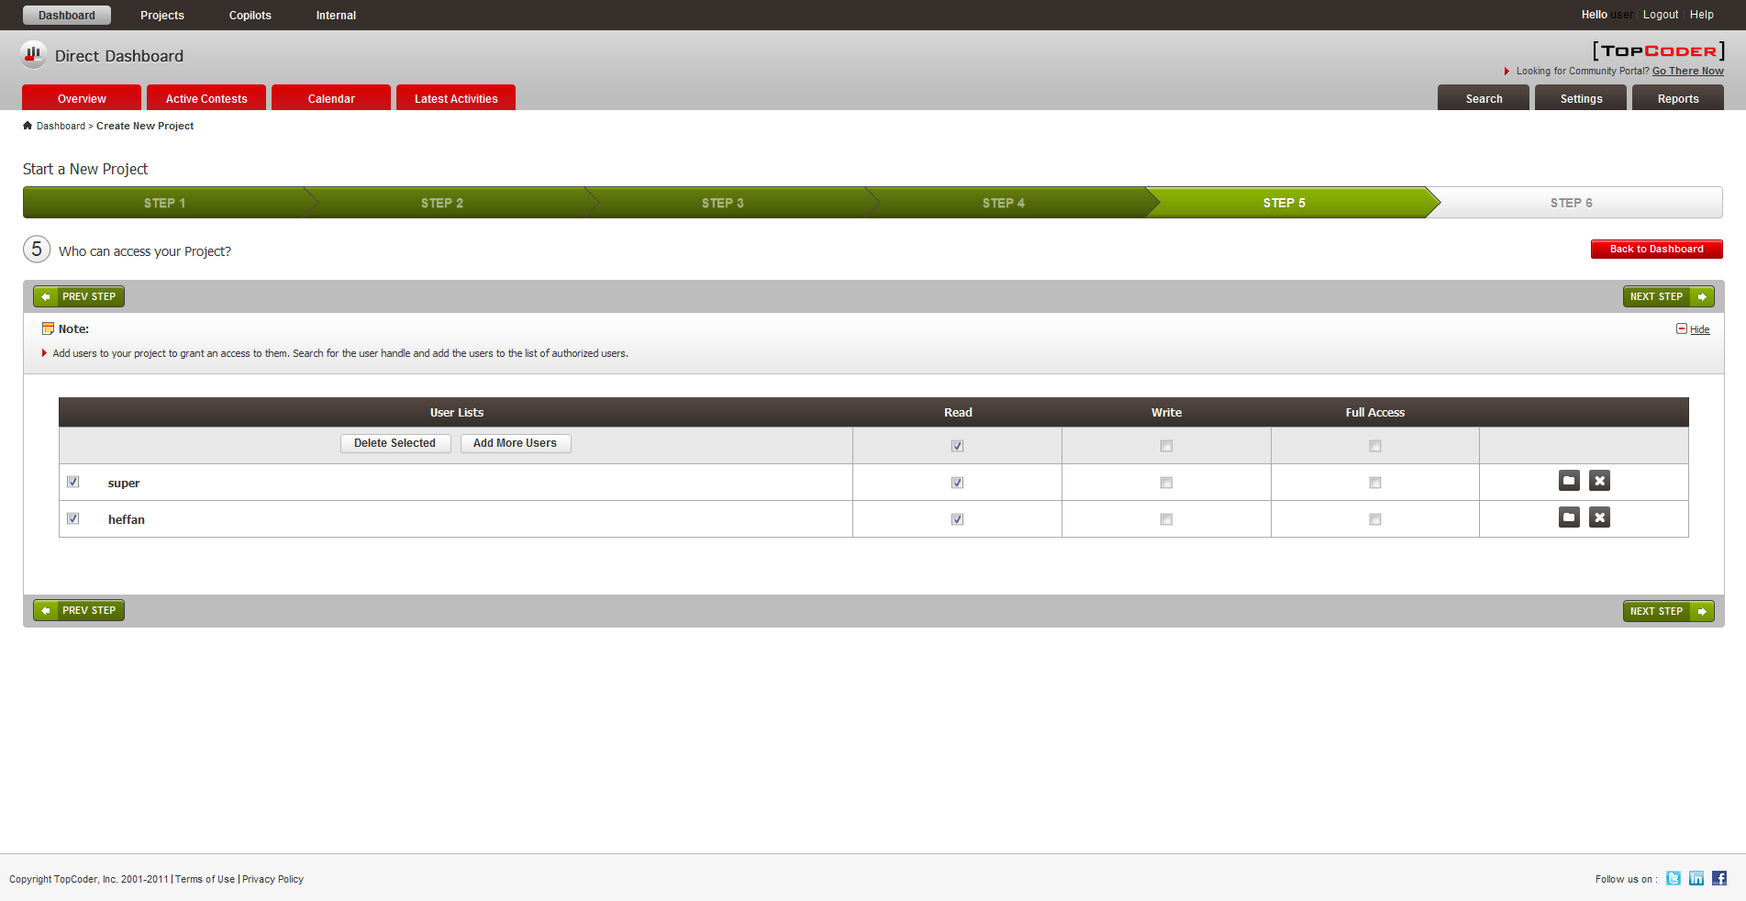

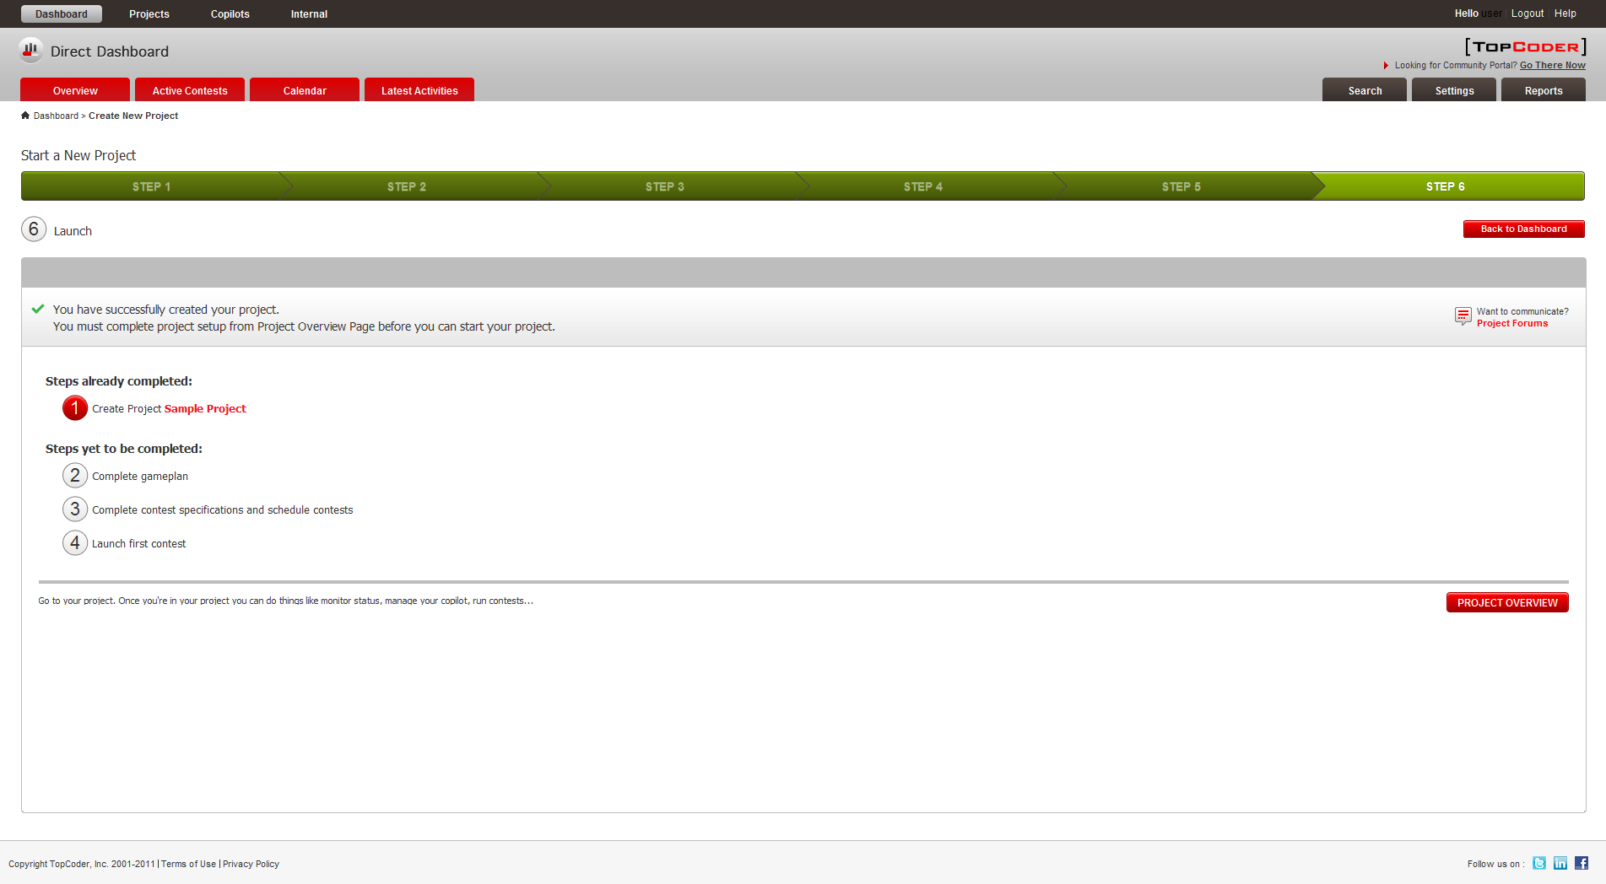
- Click Settings tab and select Permissions from "Select a Setting Panel" drop-down
  - The permissions set for newly created project must be displayed and should be editable.

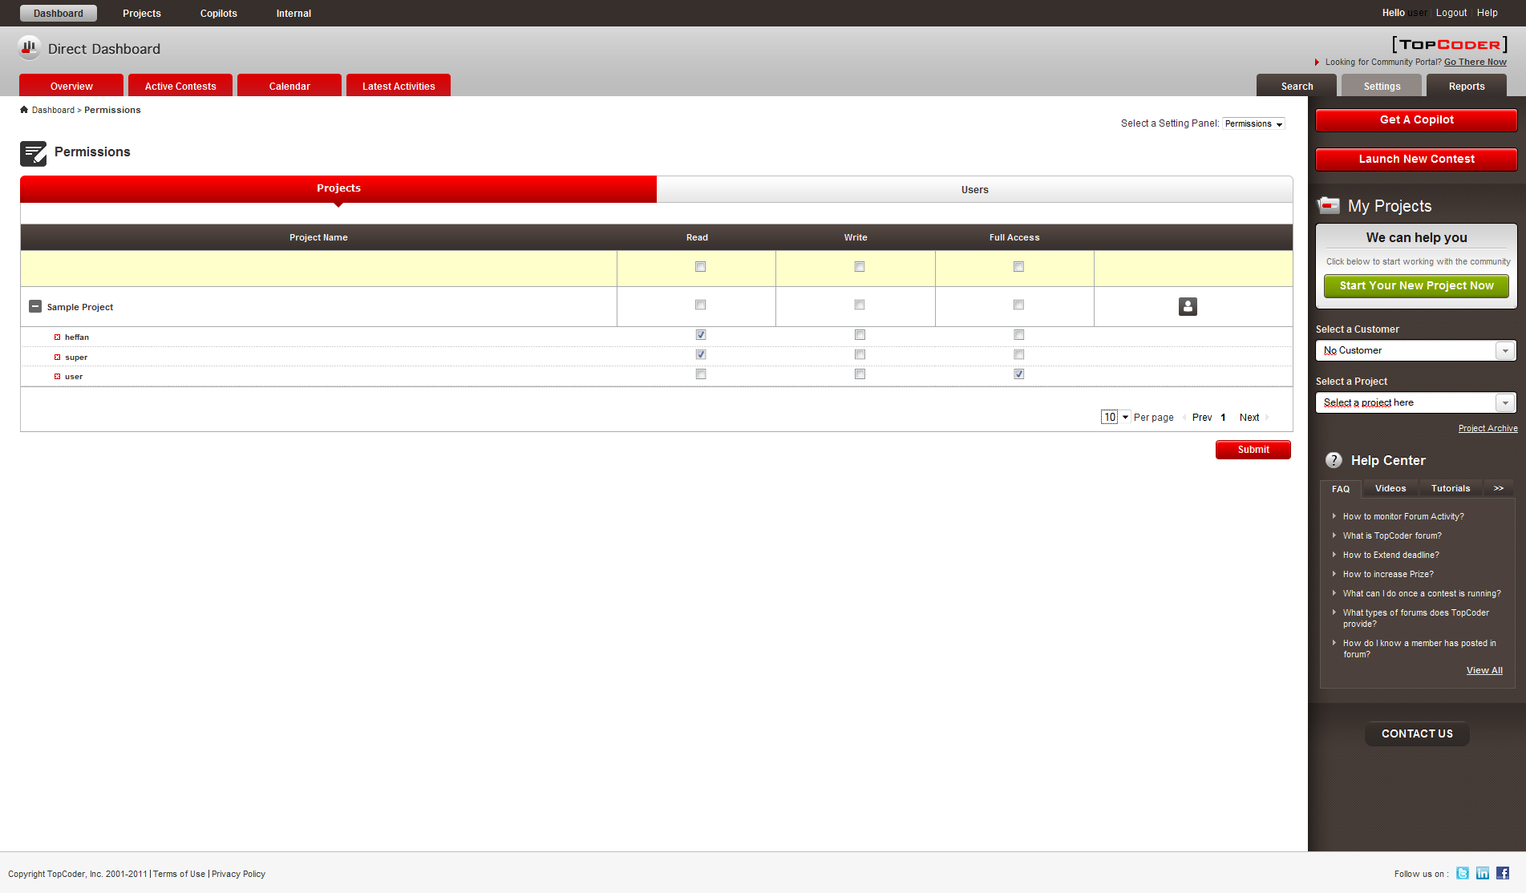
- Select just created TC Direct project from the Select a Project drop-down on the right hand panel
  - The overview page for the selected project must be displayed. The page must display CREATE PROJECT FORUM button in Project Forum area
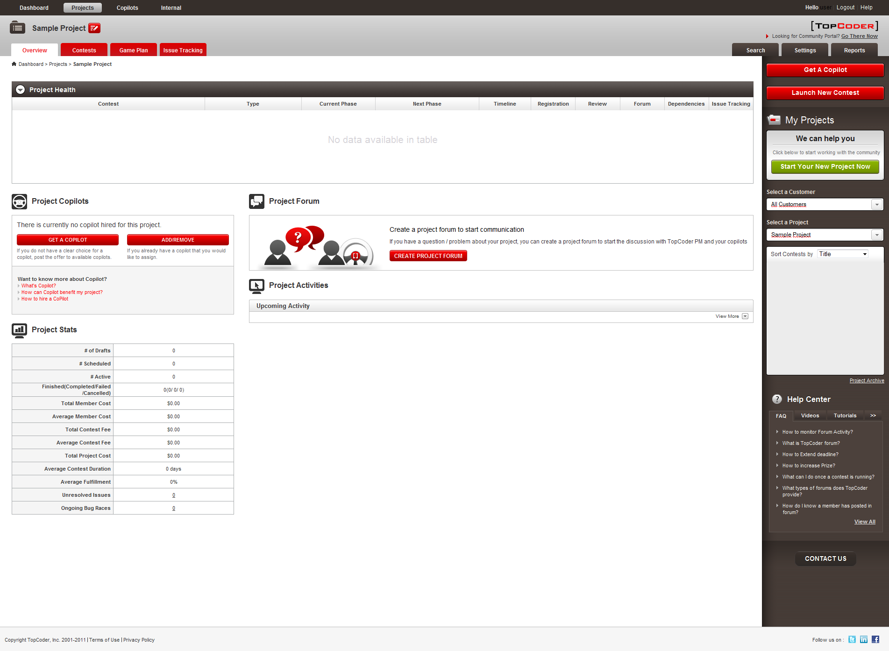

- Click Create Project Forum button
  - The forum must be created and button's label must change to Let's Talk

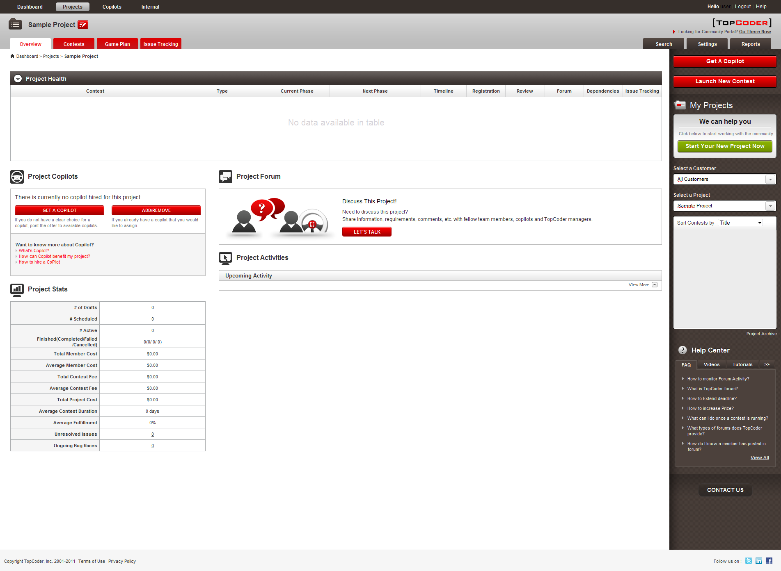

- Perform steps 5, 6 for any test project provided by test_files/test-data.sql script
  - The forum must be created and button's label must change to Let's Talk

Resource Contact List

Name | Resource Email
isv

